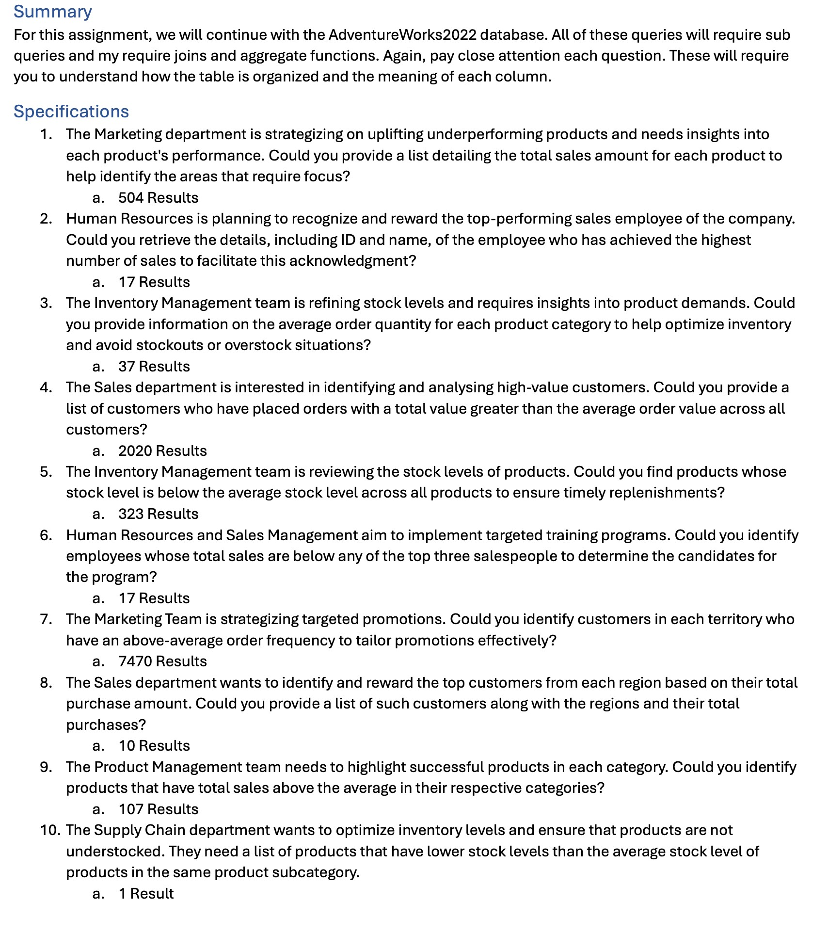

Result

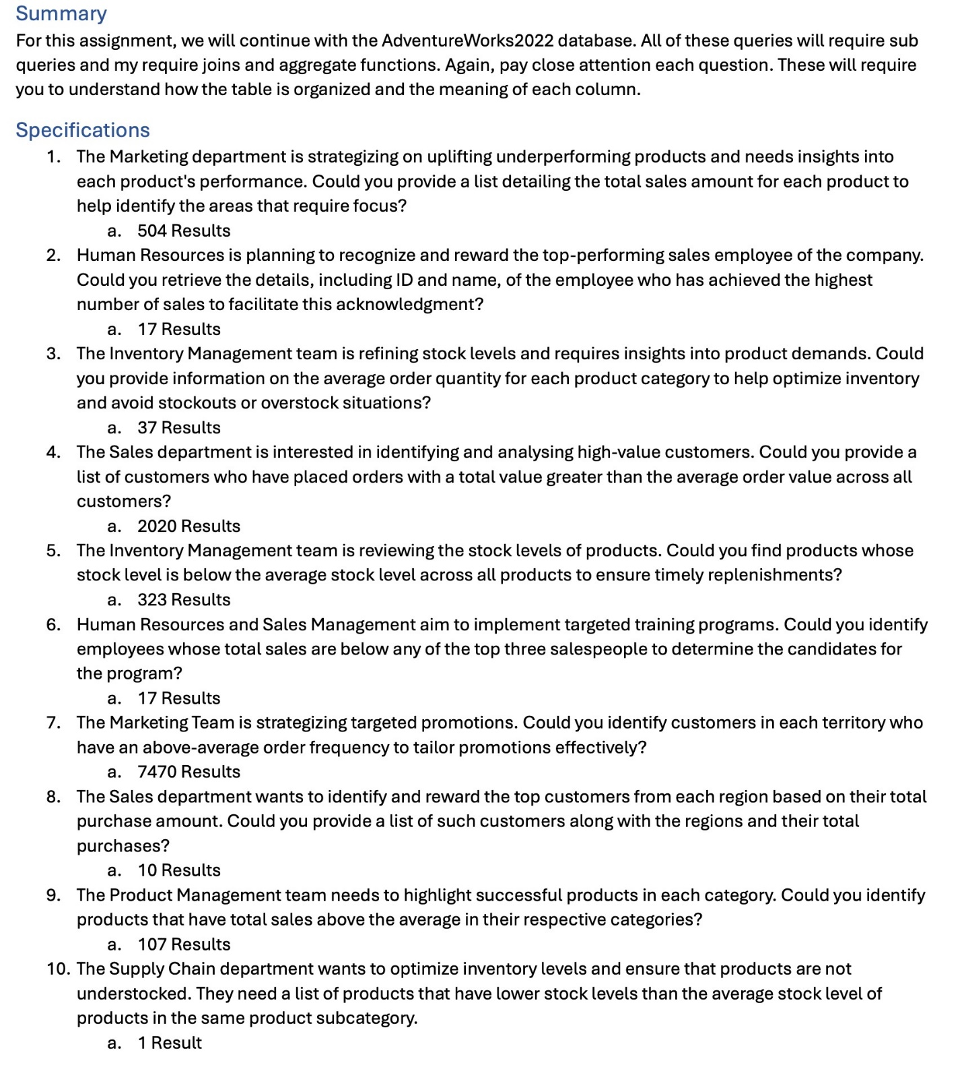

SELECT p.ProductID, p.Name, ISNULL(SUM(sod.OrderQty \* sod.UnitPrice), 0) AS TotalSales

FROM [AdventureWorks2022].[Production].[Product] p

LEFT JOIN [AdventureWorks2022].[Sales].[SalesOrderDetail] sod ON p.ProductID = sod.ProductID

GROUP BY p.ProductID, p.Name

ORDER BY TotalSales ASC;  
  
  
//Si queremos todos los empleados  
SELECT e.BusinessEntityID, p.FirstName, p.LastName, SUM(soh.SubTotal) AS TotalSales

FROM [AdventureWorks2022].[HumanResources].[Employee] e

JOIN [AdventureWorks2022].[Person].[Person] p ON e.BusinessEntityID = p.BusinessEntityID

JOIN [AdventureWorks2022].[Sales].[SalesOrderHeader] soh ON e.BusinessEntityID = soh.SalesPersonID

GROUP BY e.BusinessEntityID, p.FirstName, p.LastName

ORDER BY TotalSales DESC;



SELECT pc.Name AS CategoryName,

p.Name AS ProductName,

AVG(CAST(sod.OrderQty AS DECIMAL(10,2))) AS AverageOrderQty

FROM [AdventureWorks2022].[Production].[ProductCategory] pc

JOIN [AdventureWorks2022].[Production].[ProductSubcategory] psc ON pc.ProductCategoryID = psc.ProductCategoryID

JOIN [AdventureWorks2022].[Production].[Product] p ON p.ProductSubcategoryID = psc.ProductSubcategoryID

JOIN [AdventureWorks2022].[Sales].[SalesOrderDetail] sod ON p.ProductID = sod.ProductID

GROUP BY pc.Name, p.Name

ORDER BY pc.Name, p.Name;

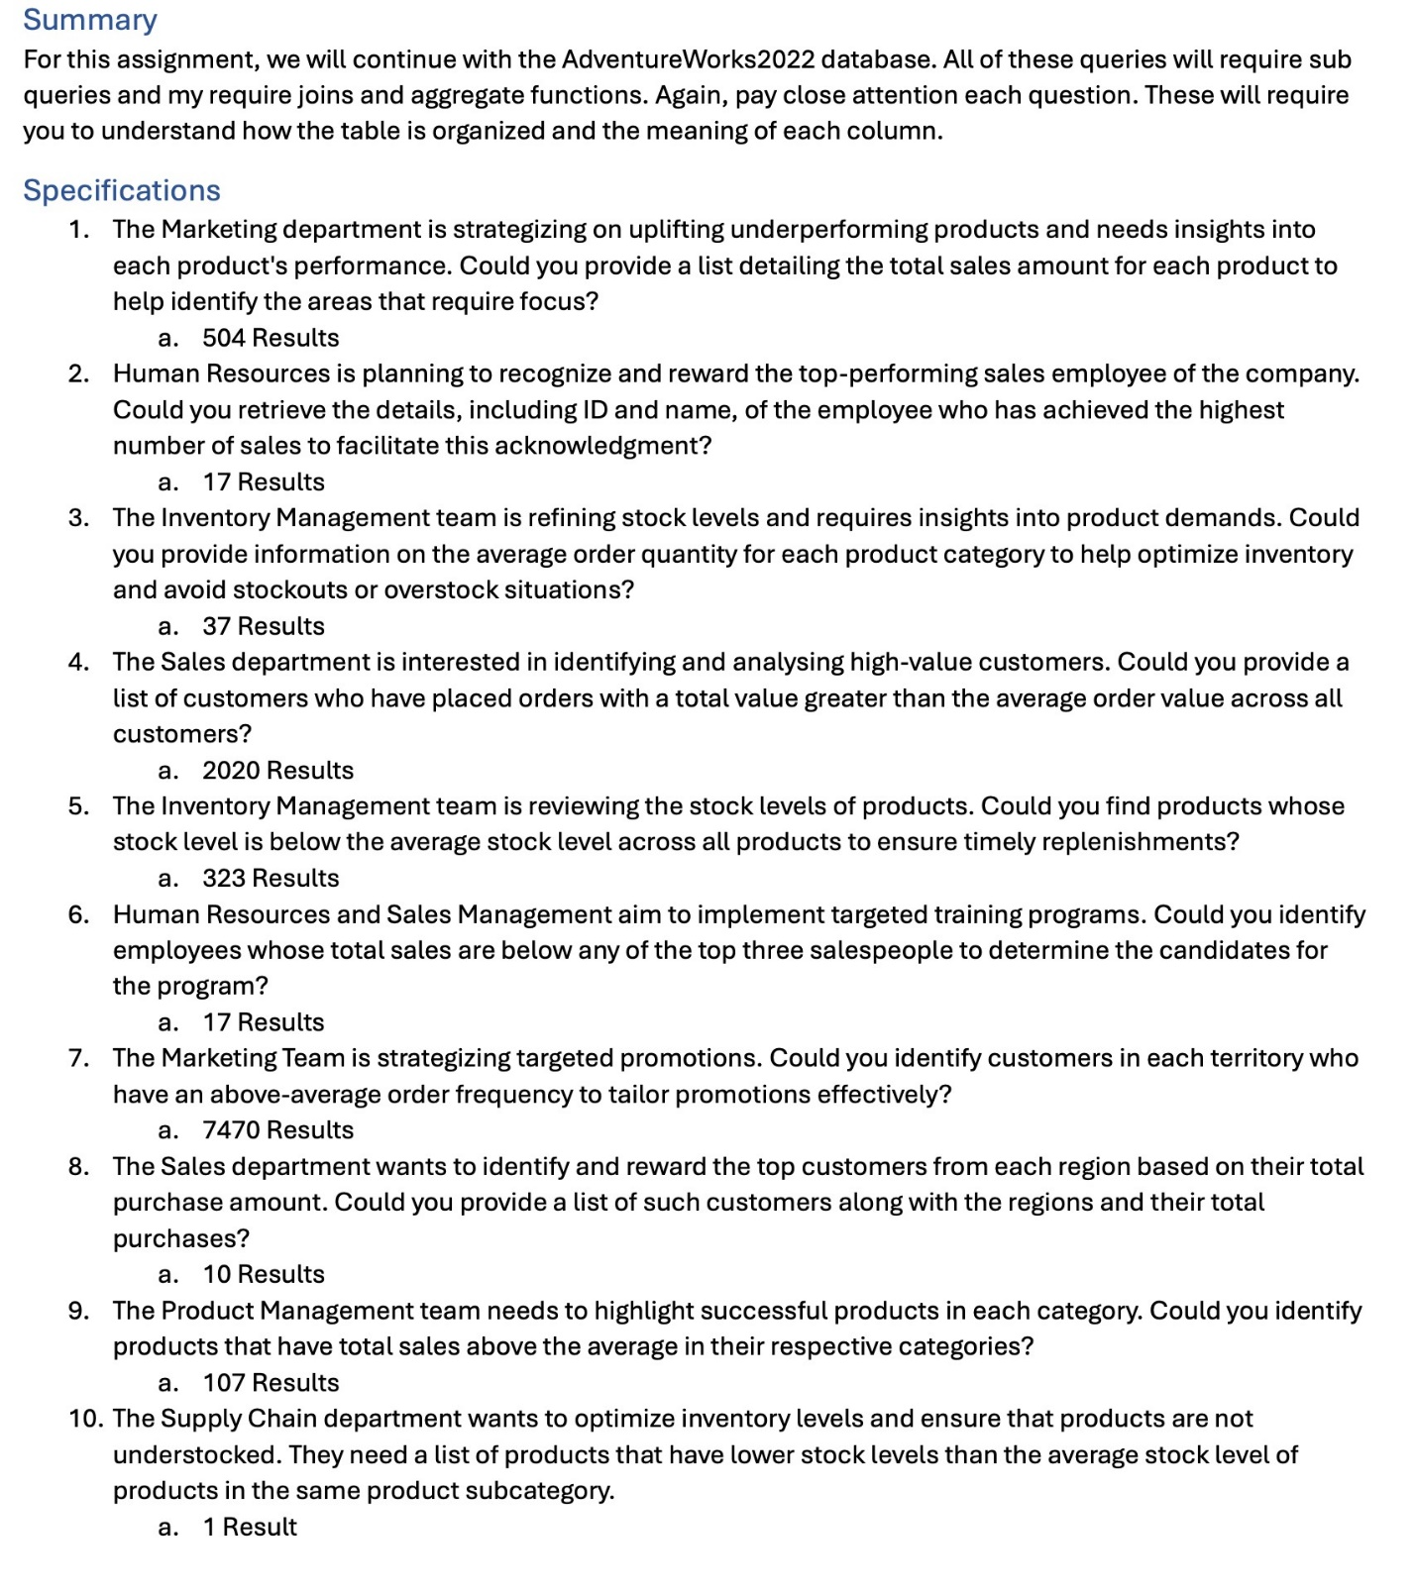

MANERA 1:

WITH CustomerOrderValues AS (

SELECT

CustomerID,

SUM(TotalDue) AS TotalValue

FROM [AdventureWorks2022].[Sales].[SalesOrderHeader]

GROUP BY CustomerID

),

AverageOrderValue AS (

SELECT

AVG(TotalValue) AS AvgOrderValue

FROM CustomerOrderValues

)

SELECT

c.CustomerID,

p.FirstName + ' ' + p.LastName AS CustomerName,

cov.TotalValue

FROM

CustomerOrderValues cov

INNER JOIN

AverageOrderValue aov ON cov.TotalValue > aov.AvgOrderValue

INNER JOIN

[AdventureWorks2022].[Sales].[Customer] c ON cov.CustomerID = c.CustomerID

INNER JOIN

[AdventureWorks2022].[Person].[Person] p ON c.PersonID = p.BusinessEntityID

ORDER BY

cov.TotalValue DESC;

MANERA 2:   
  
WITH CustomerTotals AS (

SELECT

CustomerID,

SUM(TotalDue) AS TotalValue

FROM [AdventureWorks2022].[Sales].[SalesOrderHeader]

GROUP BY CustomerID

),

AverageOrderValue AS (

SELECT

AVG(TotalValue) AS AvgOrderValue

FROM CustomerTotals

)

SELECT

ct.CustomerID,

(SELECT TOP 1 FirstName + ' ' + LastName

FROM [AdventureWorks2022].[Person].[Person]

WHERE BusinessEntityID = ct.CustomerID) AS CustomerName,

ct.TotalValue

FROM

CustomerTotals ct

CROSS JOIN

AverageOrderValue

WHERE

ct.TotalValue > AverageOrderValue.AvgOrderValue

ORDER BY

ct.TotalValue DESC;



WITH AverageStockLevel AS (

SELECT AVG(p.Quantity) AS AvgQuantity

FROM [AdventureWorks2022].[Production].[ProductInventory] p

)

SELECT

p.ProductID,

p.Name,

pi.Quantity AS StockLevel

FROM

[AdventureWorks2022].[Production].[Product] p

JOIN

[AdventureWorks2022].[Production].[ProductInventory] pi ON p.ProductID = pi.ProductID

CROSS JOIN

AverageStockLevel

WHERE

pi.Quantity < AverageStockLevel.AvgQuantity

ORDER BY

StockLevel ASC;



WITH SalespersonSales AS (

SELECT

soh.SalesPersonID,

SUM(soh.TotalDue) AS TotalSales

FROM [AdventureWorks2022].[Sales].[SalesOrderHeader] soh

WHERE soh.SalesPersonID IS NOT NULL

GROUP BY soh.SalesPersonID

),

TopSalespeople AS (

SELECT TOP 3

SalesPersonID,

TotalSales

FROM SalespersonSales

ORDER BY TotalSales DESC

),

ThirdTopSalesperson AS (

SELECT MIN(TotalSales) AS ThirdTopSales

FROM TopSalespeople

)

SELECT

e.BusinessEntityID,

p.FirstName + ' ' + p.LastName AS SalespersonName,

ss.TotalSales

FROM

SalespersonSales ss

INNER JOIN

[AdventureWorks2022].[HumanResources].[Employee] e ON ss.SalesPersonID = e.BusinessEntityID

INNER JOIN

[AdventureWorks2022].[Person].[Person] p ON e.BusinessEntityID = p.BusinessEntityID

CROSS JOIN

ThirdTopSalesperson

WHERE

ss.TotalSales < ThirdTopSalesperson.ThirdTopSales

ORDER BY

ss.TotalSales;



WITH CustomerOrderFrequency AS (

SELECT

c.CustomerID,

c.TerritoryID,

COUNT(soh.SalesOrderID) AS OrderCount

FROM

[AdventureWorks2022].[Sales].[Customer] c

INNER JOIN

[AdventureWorks2022].[Sales].[SalesOrderHeader] soh ON c.CustomerID = soh.CustomerID

GROUP BY

c.CustomerID, c.TerritoryID

),

AverageOrderFrequency AS (

SELECT

TerritoryID,

AVG(CAST(OrderCount AS DECIMAL(18,2))) AS AvgOrderCount

FROM

CustomerOrderFrequency

GROUP BY

TerritoryID

)

SELECT

cof.CustomerID,

cof.TerritoryID,

cof.OrderCount

FROM

CustomerOrderFrequency cof

INNER JOIN

AverageOrderFrequency aof ON cof.TerritoryID = aof.TerritoryID

WHERE

cof.OrderCount > aof.AvgOrderCount

ORDER BY

cof.TerritoryID, cof.OrderCount DESC;



WITH CustomerPurchases AS (

SELECT

c.CustomerID,

c.TerritoryID,

SUM(soh.TotalDue) AS TotalPurchaseAmount

FROM

[AdventureWorks2022].[Sales].[Customer] c

INNER JOIN

[AdventureWorks2022].[Sales].[SalesOrderHeader] soh ON c.CustomerID = soh.CustomerID

GROUP BY

c.CustomerID, c.TerritoryID

), RankedCustomerPurchases AS (

SELECT

CustomerID,

TerritoryID,

TotalPurchaseAmount,

RANK() OVER (PARTITION BY TerritoryID ORDER BY TotalPurchaseAmount DESC) AS PurchaseRank

FROM

CustomerPurchases

)

SELECT

rcp.CustomerID,

rcp.TerritoryID,

rcp.TotalPurchaseAmount

FROM

RankedCustomerPurchases rcp

WHERE

rcp.PurchaseRank = 1;

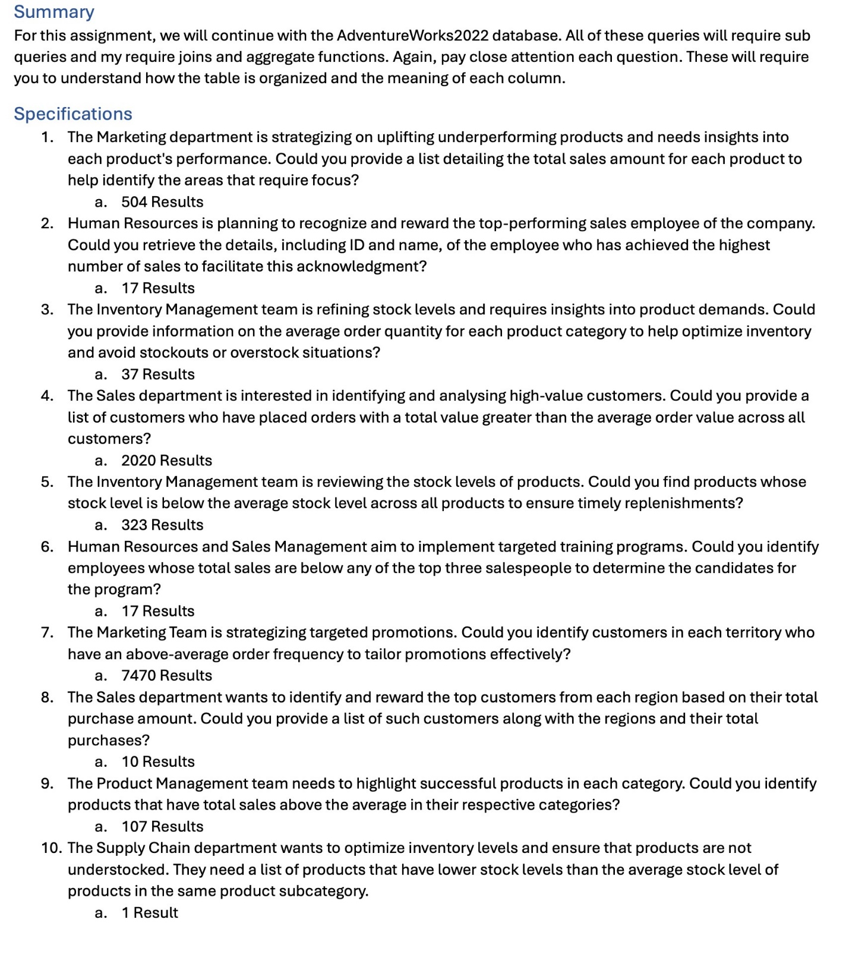

WITH CategorySales AS (

SELECT

p.ProductSubcategoryID,

SUM(soh.TotalDue) AS TotalSales

FROM

[AdventureWorks2022].[Production].[Product] p

JOIN

[AdventureWorks2022].[Sales].[SalesOrderDetail] sod ON p.ProductID = sod.ProductID

JOIN

[AdventureWorks2022].[Sales].[SalesOrderHeader] soh ON sod.SalesOrderID = soh.SalesOrderID

GROUP BY

p.ProductSubcategoryID

),

AverageCategorySales AS (

SELECT

ProductSubcategoryID,

AVG(TotalSales) AS AvgSales

FROM

CategorySales

GROUP BY

ProductSubcategoryID

)

SELECT

p.ProductID,

p.Name,

p.ProductSubcategoryID,

cs.TotalSales

FROM

[AdventureWorks2022].[Production].[Product] p

JOIN

[AdventureWorks2022].[Sales].[SalesOrderDetail] sod ON p.ProductID = sod.ProductID

JOIN

[AdventureWorks2022].[Sales].[SalesOrderHeader] soh ON sod.SalesOrderID = soh.SalesOrderID

JOIN

CategorySales cs ON p.ProductSubcategoryID = cs.ProductSubcategoryID

JOIN

AverageCategorySales acs ON p.ProductSubcategoryID = acs.ProductSubcategoryID

WHERE

cs.TotalSales > acs.AvgSales

GROUP BY

p.ProductID,

p.Name,

p.ProductSubcategoryID,

cs.TotalSales

ORDER BY

p.ProductSubcategoryID,

cs.TotalSales DESC;



WITH SubcategoryAverageStock AS (

SELECT

p.ProductSubcategoryID,

AVG(pi.Quantity) AS AvgStockLevel

FROM

[AdventureWorks2022].[Production].[ProductInventory] pi

JOIN

[AdventureWorks2022].[Production].[Product] p ON pi.ProductID = p.ProductID

GROUP BY

p.ProductSubcategoryID

)

SELECT

p.ProductID,

p.Name,

p.ProductSubcategoryID,

pi.Quantity AS StockLevel,

sas.AvgStockLevel

FROM

[AdventureWorks2022].[Production].[Product] p

JOIN

[AdventureWorks2022].[Production].[ProductInventory] pi ON p.ProductID = pi.ProductID

JOIN

SubcategoryAverageStock sas ON p.ProductSubcategoryID = sas.ProductSubcategoryID

WHERE

pi.Quantity < sas.AvgStockLevel

ORDER BY

p.ProductSubcategoryID,

StockLevel;